|  |  |  |  |
| --- | --- | --- | --- |
| 1 | | 10,728.0 | |
| NUMERO DE FRONTERAS | | ENERGIA AGREGADA | |
|  | | | |
| NO | | 0 | |
| CONTRATO | | VENCIMIENTO CONTRATO | |
|  | | | |
| 7,823,928 | 31 | | 332,524 |
| INGRESO 2021 | DÍAS CERTIFICADOS 2021 | | ENERGIA RESPALDADA 2021 |

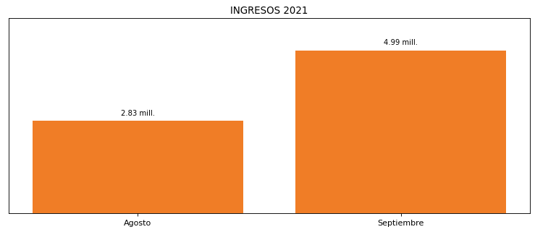

|  |
| --- |
| **PRAXAIR BARRANCABERMEJA**  USUARIO |

|  |
| --- |
| Ejecutivo de cuenta |

|  |
| --- |
| PUNTO FOCAL |

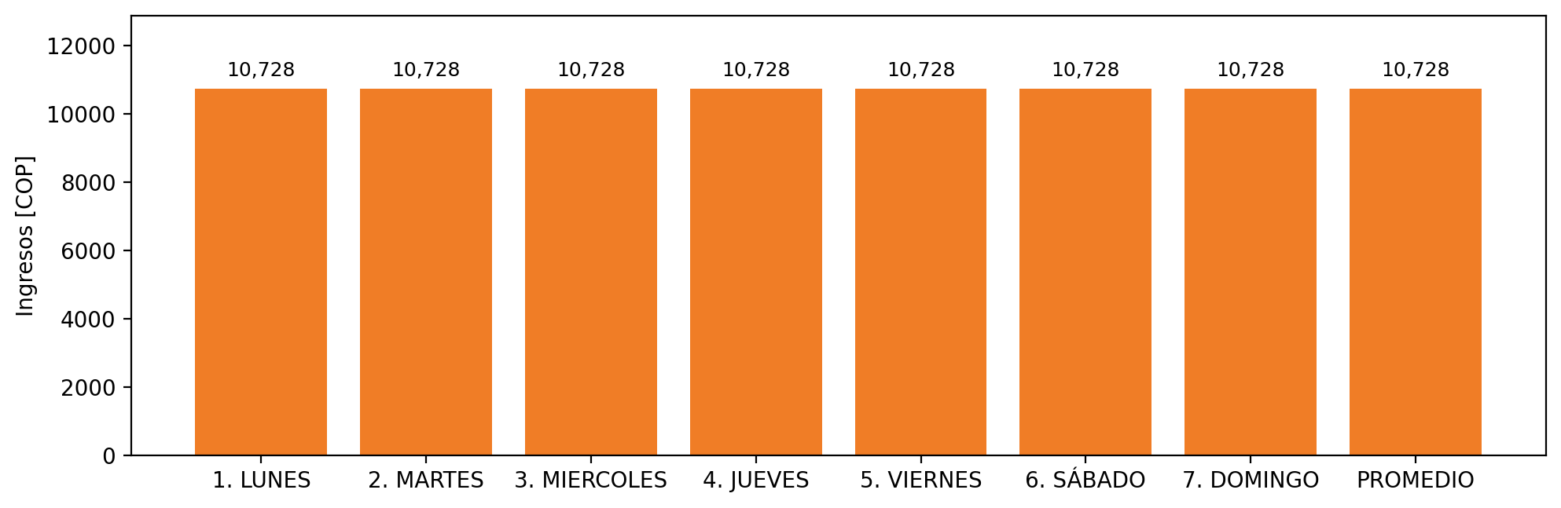

|  |  |  |  |  |  |  |  |  |  |  |
| --- | --- | --- | --- | --- | --- | --- | --- | --- | --- | --- |
| **FRONTERA** | **COD SIC** | **PREDIO** | **FRT DDV** | **TIPO DDV** | **PROMEDIO** | **PRÓXIMA ACTUALIZACIÓN** | **MARGEN DE ERROR** | **ÚLTIMA PRUEBA DDV** | **DÍAS PARTICIPACIÓN** | **FECHA REFERENCIA PRÓXIMA PRUEBA DDV** |
| PRAXAIR BARRANCABERMEJA | Frt07461 | Prd02245 | Frt42062 | MI | 10,728 | 2026-04-15 | NO APLICA | 2021-08-09 | 31.0 | 2022-01-07 |